Quality Assurance in my life

Quality Assurance is a skill one does not have the ability to turn off once acquired. These are real world examples I have encountered in my life.

Contents

Pricing changes 2
Haphazard System 3
Ancestry.com Woes 5
Bad Pre-Requirement Check 6
Writing Center Hauntings 8
When You Know the System Too Well 9

Pricing changes
LinkedIn post

Today, I went to Hobby Lobby. I was going to buy 2 needle threaders. I only bought one. Hobby Lobby is in the middle of raising prices and I caught an issue and complained about it.
One threader was priced as 99¢. The other was $1.49. I bought the 99¢ one and refused to buy the $1.49 one.
I then went to the manager and told him my issue. My issue wasn't the fact the price went up. My issue is when someone restocked the threaders, they left inventory that had inconsistent pricing on the shelves. This is not the first time I have seen it, but the first time I complained.
The manager was willing to sell me the second one for 99¢, but I said no.
I bring this up as an example of Quality Acceptance and doing a job correctly. I know things can be overlooked. But how is it ever going to change if someone doesn't bring it up? The employees need to make sure after a price increase, that all the prices are consistent.
I probably would have bought both had they both been either 99¢ or $1.49.

Why I mentioned this: Quality assurance and quality control are concepts that expand outside of the information technology system.

Haphazard System
LinkedIn Post
At the moment, I am just in the QA mode. At the moment, I am working on my family tree on Ancestry and a little puzzled about the media section.
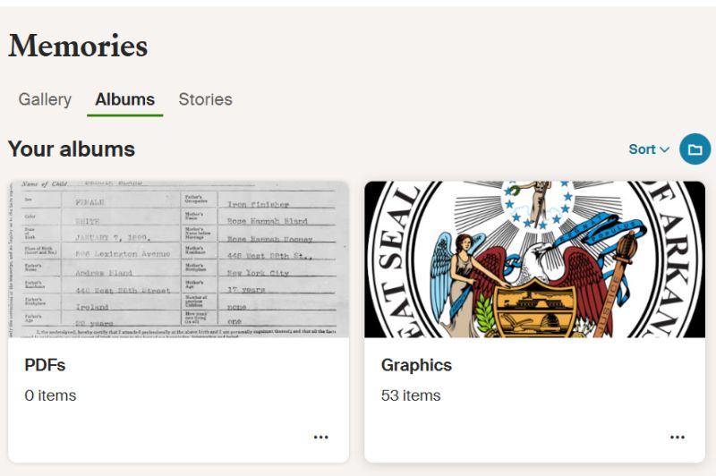
If you are able to get your albums to load, you can sort your albums as needed. However in the upload section, you can't sort nor filter your media to add items to an album.
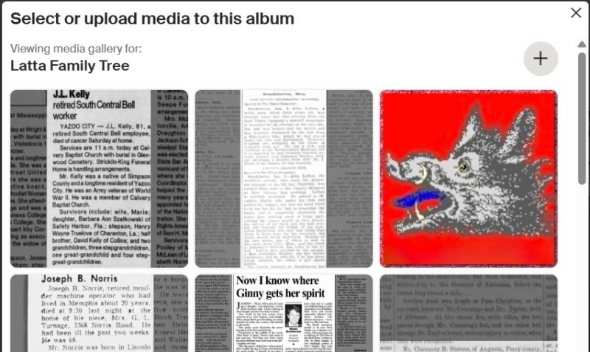
I'd like to sort my media to use the albums feature and place my files into folders. I can't at the moment. There is a limit of how many file thumbnails it will load. If the document you want is in the system prior to the last file loaded, you can't add it.

Why I mentioned this: I see issues in other websites as well. On this particular day, I was working on my family tree and noticed sorting functionality was limited to the album functionality, but there was no sorting functionality within adding a file from the media gallery. The entire concept of media gallery and media organization should have consistent traits.

Ancestry.com Woes
LinkedIn Post
More Quality Assurance and Debugging in real life:
I detest JAVAScript heavy web pages.
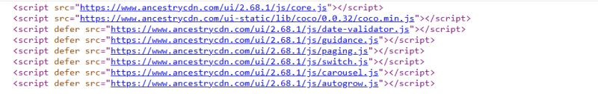
For example, Ancestry is giving me issues. I can't seem to get certain processes to work for me. Mainly, merging 2 profiles, but there are more. I took a look at the source code. I see two sections of code that alert me to JAVAScript. First section is showing me a lot of JAVAScript is being used in this 1 page. I know the AJAX concept is to make data to be on the fly, but if everything is JAVAScript, like the Merge button as seen in the second screenshot, it leaves to me be frustrated. I can't go into the source code of the page and just use a straight link.
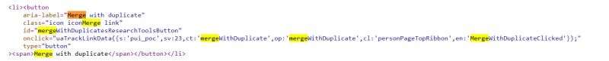

This leave[s] me, as the user, frustrated. All I see is a website that isn't working.
With my coding background, it makes me frustrated. I don't know if the JAVAScript error is in their code or my browser. I don't have time to sit down and decode all the .JS files to find the link to the page to force a merge.
If only a comment was included in the source code to provide a simple link.

Why I mentioned this: I try to debug as a far as I can. I look at source code to see if I can find an alterative way to process webpage.

Bad Pre-Requirement Check
LinkedIn Post
There is a comment in this discussion about knowing what to use in ATS and it's just Boolean. In the comment, they say "You have to update to what fits" and bad results come from bad inputs.
They could be correct in the bad searches, but could it also be bad inputs into the system itself. I have such a real life example from my college days.
My school offered Programming 1101 in an honors and non-honors version. I took the honors version. The class was identified at 1101H.
When it came time to enroll in 1102, they did not offer a 1102 honors version. The enrollment system checked if you took the pre-req 1101 before allowing you into 1102.
When I went to enroll, the system used did not recognize 1101H was the same as 1101. No one had coded it or configured the software correctly to parse out the H and see 1101 only or say that 1101H was a suitable pre-req for 1102.
For you coders out there, that's either 2 entries in the DB for pre-reqs or code to strip the H off the end of 1101H and process the rest of the code using 1101 as the input in the source code.
That one example always sticks out in my mind about garbage inputs results in garbage outputs. That one example is why QA is important to me.
Thankfully, the professor teaching the 1102 I wanted to take was the professor I took for 1101H. He was able to override the system to get me into that class before it was filled.
My issue was I should not have to go get an override to enroll in a class. That system should have been coded to know 1101H was just as acceptable.
That seems to be my life. I always seem to be that odd scenario where overrides and reconfigurations are needed to accommodate me.

Why I mentioned this: This is a great example of why requirements need to be reviewed and all situations that are possible are scoped out. I know it’s possible not to code a system to handle all situations but at least having them scoped out can allow you to make a standard operating proceed documentation (SOP) for future reference.

In my example, the system needed to be able to parse the H in a way to recognize that my completion of 1101H is the same as 1101 to enroll in 1102.
Looking back at the course catalog, I took CSCI 1301H - Honors Introduction to Programming Principles, not 1101H. This is how the catalog had CSCI 1302 - Advanced Programming Principles.
Per the catalog course descriptions:
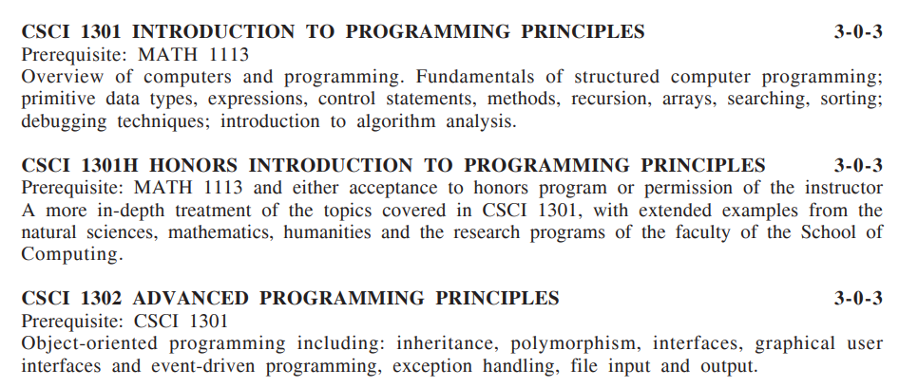
The catalog denotes that CSCI 1301H is a bit more extensive than CSCI 1301. However, CSCI 1301H is still a CSCI 1301 level class.
If the course catalog was provided as the system’s business rules, the system was coded to look for the only provided. The error is on the catalog side for not having CSCI 1301H listed as a prerequisite.
To be fair, looking at ENGL 2100H, another Honors class I took, I see ENGL 1102H as a prerequisite for ENGL 2100:
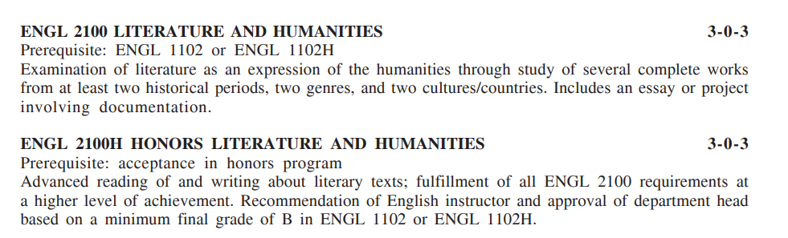
This issue I encountered didn’t have to happen if there was consistency in the catalog verbiage and the system functionality.

Writing Center Hauntings
LinkedIn Post
I think some of my Quality Assurance skills go way back to college. I worked at the Writing Center. It amazes me I was even hired to work there, but it was my enjoyment of history that was my main asset for that position. To be honest, I can't spell and produce a lot of typos, but when I read others' work, I can't help but notice items like "Most Quaker communities flourished in the northeast corner of the colony, near the Dismal Swamp and the Virginia boarder. "
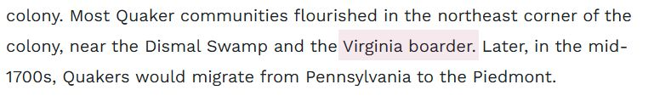
It should be BORDER.
Why I mentioned this: I can not just turn off my Writing Center skills. Growing up, my mother was strict on our grammar. She was strict because she was the daughter of a newspaper reporter. She wasn’t afraid to use extensive vocabulary around us.
When I had to make changes to a personal communication statement, if I noticed a typo that made it into production, I just went ahead and corrected it. For oddly worded phrasing, I would make a note and ask about it, explaining why it was awkward, and suggest a change to our operations team. Sometimes my changes were accepted. Other times, they weren’t, but operations could see why I suggested the change and make a change their liking, while acknowledging my suggestion.

When You Know the System Too Well
LinkedIn Post
My QA skills have kicked in. In fact, this is what I used to do for a living when Alight Solutions was still Hewitt. I would look at the system from the perspective of a client's employee. Some of the cases would be negative test cases for ineligible participants.
Today, I am an ineligible participant on the Alight System. When my subsidy from my layoff expired, I terminated my COBRA coverage. I had COBRA for Medical, Dental, Vision, and Employee Assistance Plan (EAP).
I went to see the Health Summary page and scrolled to the bottom. See the picture attached to this post.
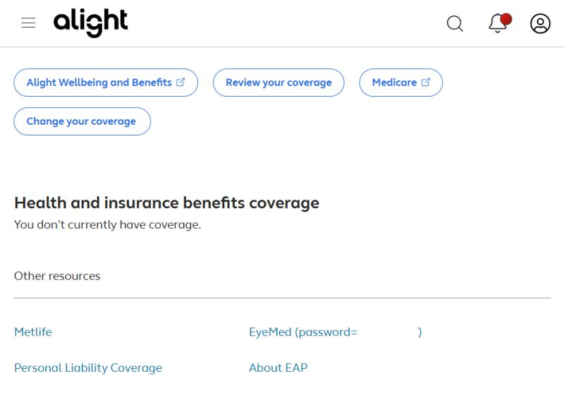
For my testing, for my clients, I would not expect to see the following links in my screenshot under the other resources:
1) A link to EyeMed with the password! I know EyeMed is a fully insured plan (100% out of the employee's pocket), but I am not eligible for it. My COBRA status would be one of ineligibility. I think it's the password that gets me the most. I removed it from the screen shot. A password in this case is no different than PII displaying.
2) About EAP link. EAP is a COBRA eligible plan. Again, my status would be one of ineligibility. It's been a year since I chose to terminate coverage. I know I had at least 18 months on my eligibility, and I'm not at the 18 month mark, but when I ended coverage, I should have lost my rights.
For both plans, I see an issue that if I wanted to, I could try to say Alight would have to cover me since I'm being offered those links. I wouldn't do it, but there's a person out there that would do it. I would log it as a potential issue.
I'm not so bothered by the Met Life and Personal Liability links. It's possible to have converted those plans with a Portability of Coverage Notice to be fully insured and paid for in my name.
My questioning comes in to play and I would research what is the driver that determined the EyeMed and EAP Links showing up on my screen. I would look at provisions to see if I should even be seeing these links. I would report it as an issue and provide documentation just like I am doing. I would also throw in a suggestion as to how to address a better way to display this data and make sure the employee understands that a link provided for EyeMed and EAP does not mean I am eligible for it.
This post is only written because I needed to check on my retirement items I still have with Alight. Curiosity just got the best of me.

Why I mentioned this: This whole issue is the crux of my role at Alight. I started off working as an acceptance tester. QA work. We were originally promised that we would alternate iteration work with one iteration being configuration and the other one being a testing iteration. I was scheduled to do Annual Enrollment (AE) testing for the iteration. When the COBRA (Consolidated Omnibus Budget Reconciliation Act) subsides of 2009 were implemented, I was pulled into the project to test. This is where I became knowledgeable in COBRA. I didn’t know the basics about COBRA; I had to ask a lot of questions. When my testing was completed, my team leader felt confident about the system changes between the AE and COBRA work. For the next iteration, when I was scheduled to do configuration, I was pulled side by my leader and told me she was having me continue with acceptance testing with the second AE of the year our team performed. She was impressed by my work and the feedback on my work that she wanted our second AE to be just as successful.
It is ingrained in me to QA Alight Worklife when I see it.

